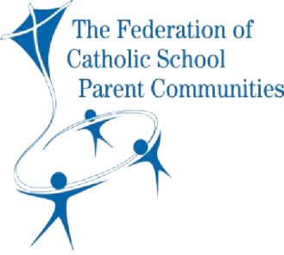

**Characteristics of Effective Teams**

**In effective teams, members:**

* Have a common purpose
* Share a common language
* Appreciate the value of a supportive culture
* Listen to, and genuinely consider, other members’ ideas and concerns
* Understand what needs to be done and are committed to achieving this
* Have a dual focus on achieving tasks and developing the team
* Agree how to proceed, and allow time for discussion about specific actions
* Share the work to be done and feel included in the team
* Leverage the team’s diversity – learn about, and make use of, other members’ knowledge, talents and interests
* Strive to improve their own work, and the team’s work
* Collectively develop strategies to resolve problems and solve blockages
* Share leadership and support each other to grow as leaders