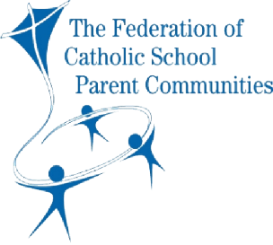**TIPS FOR EFFECTIVE MEETINGS**

**TROUBLESHOOTING DISCUSSIONS**

* **When the discussion moves away from the main topic**

The Chair or a member should point this out and/or ask a question that is relevant to the main topic.

* **When there is uneven discussion**

The Chair or a member can suggest it would be good to hear from members who haven’t yet spoken – and help to create the space for this to then happen.

* **When discussion is too rapid**

It can be difficult for all members to grasp the details and importance of matters when some are better informed than others. The Chair should politely interrupt and ask for briefer comments on the main points or, alternatively, attempt themselves to summarise what has been said and then ask if members have any questions.

* **When statements made are obviously or quite likely wrong**

The member can politely be asked for facts to support the statements and the source of these, and/or to clarify what they know and what they are assuming.

* **When discussion is embarrassing or getting personal**

The Chair must maintain a neutral voice and politely but firmly stop the discussion, state that what was being said is not appropriate, and re-group all members to focus on the objectives of the meeting.

If discriminatory or offensive language is used, the Chair must immediately stop this and the member(s) concerned should properly apologise.

* **When the discussion gets out of control**

The Chair can ask for all members to stop and quietly reflect for a moment on the topic and their emotions, before calling a short break.

After the break, the Chair should go around the table, asking members one by one to briefly summarise their view (without going into further explanation), and then ask a question like ‘So how can we solve this?’ The alternative is to propose a solution and ask for comments on this. If further progress can’t be made, the Chair should suggest the topic is left for the time being and commit to return to it in the not-too-distant future.