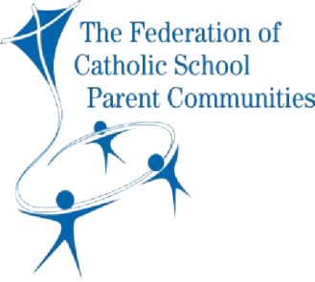

**RESPONSIBILITIES OF FORMAL PARENT GROUPS**

**ALL MEMBERS**

***‘Leadership is using your influence for a worthwhile cause’***

**All group members are ‘parent leaders’ who share responsibility for the success of the group, its activities and its impact.**

* Be open to share your time, talents, energy and expertise for the benefit of the group and the wider school community.
* Attend meetings as regularly as possible and be as punctual as possible.
* Prepare well by reading the previous minutes, the agenda and any other documents that have been distributed.
* Actively listen when others are speaking (listen with your eyes and ears; ask questions to better understand; don’t interrupt or talk over the top, use positive body language).
* Signal to the Chair when you would like to say something and address the Chair when you are invited to speak. This helps the Chair to run an orderly meeting and to prevent across-the-table or side conversations between individual members.
* Present your own views as clearly as you can. Keep to the point.
* Don’t monopolise meetings by talking for too long or being the first to speak on lots of agenda items. Help to ensure every member is given the opportunity to speak on matters of importance, and shy people are encouraged but not embarrassed.
* Always have a co-operative mindset. Take an interest in all matters being discussed. Do your best to help the meeting run smoothly and finish on time.
* Privately and politely take up any concerns you have with the Chair.
* Maintain complete confidentiality where this is required or might reasonably be expected.
* Actively support consensus and majority decisions once these have been made. It is important to voice your concerns up until a decision is made. After that, it is important to accept the decision and not undermine it, for example, by distancing yourself from it, complaining to others, trying to recruit others to overturn it or not helping to effectively implement it.
* Send an apology for any meeting you are unable to attend.